Java Virtual Machine
JVM
Virtual machine:
It’s a software simulation that does not have physical exitance and can perform operations like physical machine.
Type of virtual machines:
- Hardware/System base.
Refers to systems that depend on the physical components of a computer (CPU, memory, storage, devices) and the operating system to effectively utilize Hardware resources. (Not for programmers)

- Application/Process base.
Refers to systems that run as programs or tasks on top of the operating system, performing specific user functions or as run time engine for programming language Application. (where programmers involve).
JAVA Development Tool Kit (JDK): is a software development environment that provides tools, libraries, and runtime components required to develop, compile, debug, and run Java applications.

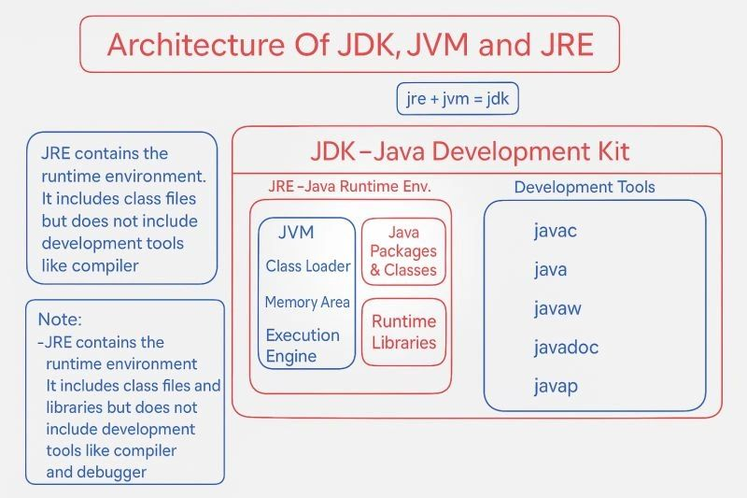

JVM: A process based virtual machine which acts as run-time engine to load & run java program line-by-line & functions as part of JRE which is part of JDK.

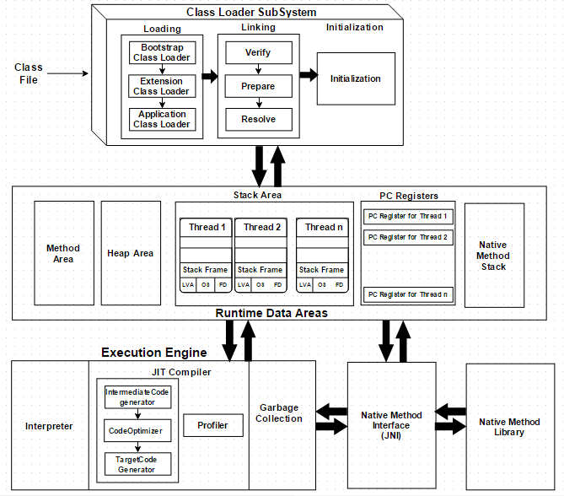

Class loader sub-system: responsible for loading Java class files (.class) into memory (Runtime Data Area) when a program runs.
It’s responsible of 3 main tasks:
- Loading: Loading is the process of reading .class files (bytecode) form hard desk and store corresponding binary information (related class name, immediate parent, type: class, interface or Enum, constructers info, modifiers info, methods info, constant info & variables info) in the Method area.

After loading every .class file JVM will create an object of type class to represent the total .class file binary information to be accessed by the programmer for accessing class level object binary information & the created object will be stored in Heap Area.

The created object it is not an object of the red class; it’s an object of type class (class-class-object).

For every load/red .class file JVM will only on class-class object even if it’s used many times across the program.

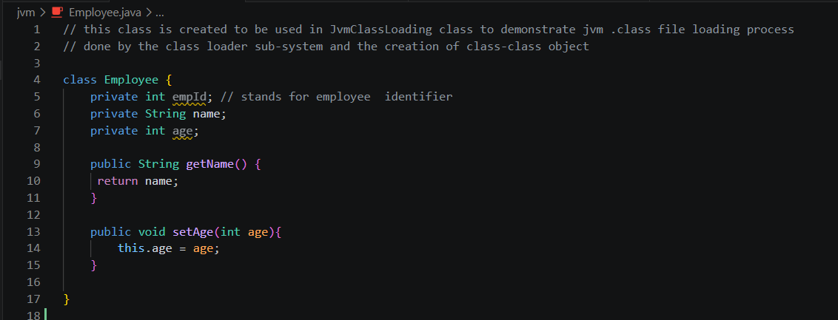

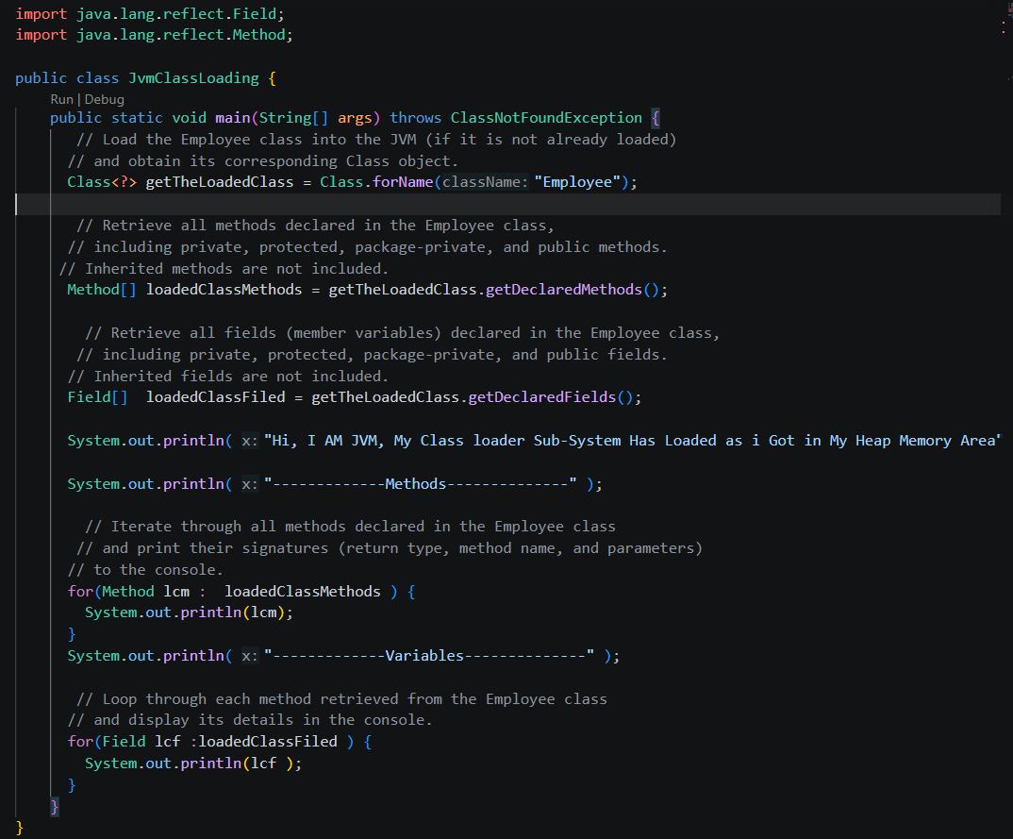

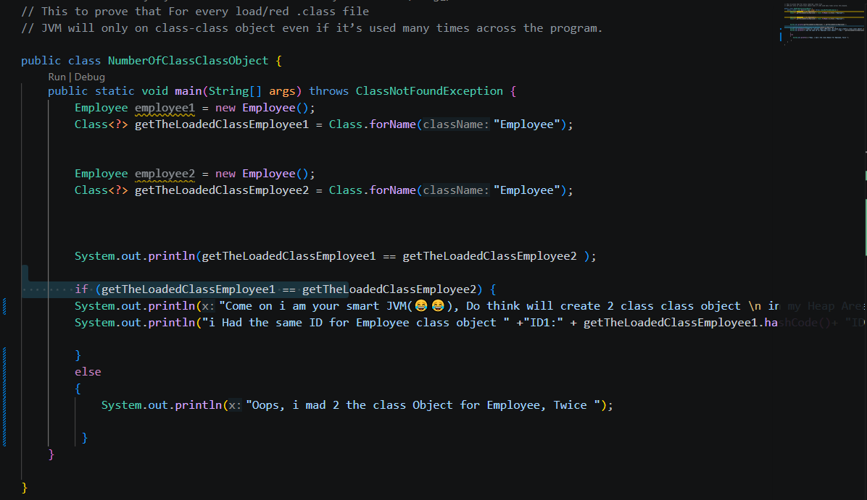

Initialization: is the final phase of the class loading process in which the JVM assigns actual values to static variables and executes static blocks of a class.

- Linking: Linking is the process of preparing the loaded class so it can be used safely and correctly.
Verification: is the process of checking whether the loaded bytecode is structurally correct and safe to execute according to JVM specifications and it’s done by bytecode verifier.
Preparation: is the phase where memory is allocated for class-level static variables and they are assigned default values.
Resolution: is the process of converting symbolic references in the class into direct memory references in the constants pool of the parent class.

- Initializing: the process where actual values are assigned to static variables and static blocks are executed.

“If compilation is fine but runtime class connection fails → LinkageError”

Types of class loaders:
- Bootstrap class loader: is the root class loader in JVM that loads core Java classes from the JDK internal runtime libraries.
Type: Native class loader (part of JVM, written in native code)
Loads: Core Java classes like java.lang.*, java.util.*, java.io.*
From where: $JAVA_HOME/jre/lib (or modules in modern Java)
- Extension class loader: loads classes that extend core Java functionality from the extension library directory.
Type: Java-based class loader
Loads: Extension classes (non-core Java libraries)
From where: $JAVA_HOME/jre/lib/ext (or platform modules in Java 9+)

- Application class loader: loads classes from the application classpath, including user-defined classes.
Type: Java-based class loader
Loads: Application-specific classes written by the developer
From where: Classpath (-classpath or CLASSPATH environment variable)

How java class loaders work?
Java class loaders use the Parent Delegation Hierarchy Algorithm to load classes efficiently and securely. When a class is requested, the Application Class Loader first delegates the request to the Platform Class Loader (Extension), which then delegates it to the Bootstrap Class Loader. The Bootstrap Class Loader attempts to load the class first. If it cannot find the class, the request is passed back to the Platform Class Loader, and finally to the Application Class Loader. If none of the class loaders can locate the class, the JVM throws a ClassNotFoundException. This delegation model prevents duplicate class loading, ensures that core Java classes are loaded by the trusted Bootstrap Class Loader, and improves the security and consistency of the JVM.

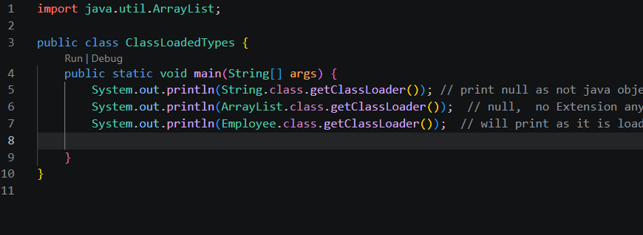

Runtime Data Area: the memory area used by JVM during program execution & represent the storage for class file to be executed.
Method Area
The Method Area is a shared memory area of the JVM that stores class-level information, such as class metadata, method bytecode, static variables, and the runtime constant pool. It is shared among all threads.

Heap Area
The Heap Area is the runtime memory where objects and instance variables are allocated. It is shared by all threads and is managed by the JVM's Garbage Collector, which automatically frees unused objects.

Stack Area
The Stack Area is a memory area where each thread has its own stack to store method call information, including local variables, method parameters, return addresses, and intermediate results. Each method call creates a new stack frame, which is removed when the method finishes execution.

Program Counter (PC) Register
The Program Counter (PC) Register is a small memory area that stores the address of the current JVM instruction being executed by a thread. Each thread has its own PC register, allowing multiple threads to execute independently.

Native Method Stack (Native Method Area)
The Native Method Stack is a memory area used to support the execution of native methods, which are methods written in languages such as C or C++. It stores information related to native method calls and works together with the Native Method Interface (JNI) to enable interaction between Java code and native libraries.
Execution Engine: the part of JVM that executes line-by-line the bytecode after it is loaded.
Interpreter
The Interpreter is a JVM component that executes Java bytecode line by line, converting each instruction into machine code during runtime. It provides quick startup but slower execution for repeated code.

JIT (Just-In-Time) Compiler
The JIT Compiler improves performance by converting frequently executed bytecode (hot spots) into native machine code, so it can run faster without repeated interpretation.

Intermediate Code Generator
The Intermediate Code Generator converts source code into platform-independent intermediate code (bytecode or IR), which acts as a bridge between source code and machine code.

Code Optimizer
The Code Optimizer improves intermediate code by removing redundant instructions and improving efficiency, making the program faster and more memory-efficient.

Target Code Generator
The Target Code Generator converts optimized intermediate code into final native machine code that the CPU can execute directly.

Profiler
The Profiler is a JVM tool that monitors program execution to analyze performance, memory usage, CPU usage, and method execution patterns

Native Method Interface (JNI): is JVM component that allows Java code to communicate with code written in other programming languages like C or C++.

Native Method Library: a collection of pre-written code written in languages like C or C++, which Java can use through JNI (Java Native Interface).
A Custom Class Loader: is a user-defined class loader in Java that is created by extending the ClassLoader class. It allows developers to load classes in a custom way instead of using the default JVM class loaders (Bootstrap, Platform, Application).

- Used in application servers like Tomcat, JBoss, WebLogic to isolate multiple applications.
- Used in plugin systems (Eclipse, IntelliJ, Minecraft mods) to load features dynamically at runtime.
- Used in frameworks like Spring and Hibernate for dynamic class loading and scanning.
- Used in security systems to restrict or control which classes can be loaded.
- Used for loading encrypted or obfuscated classes by decrypting bytecode before loading.
- Used in cloud and microservice platforms for module isolation.
- Used for hot deployment, allowing class updates without restarting the JVM.
- Used in modular systems (like OSGi) to manage independent components.

